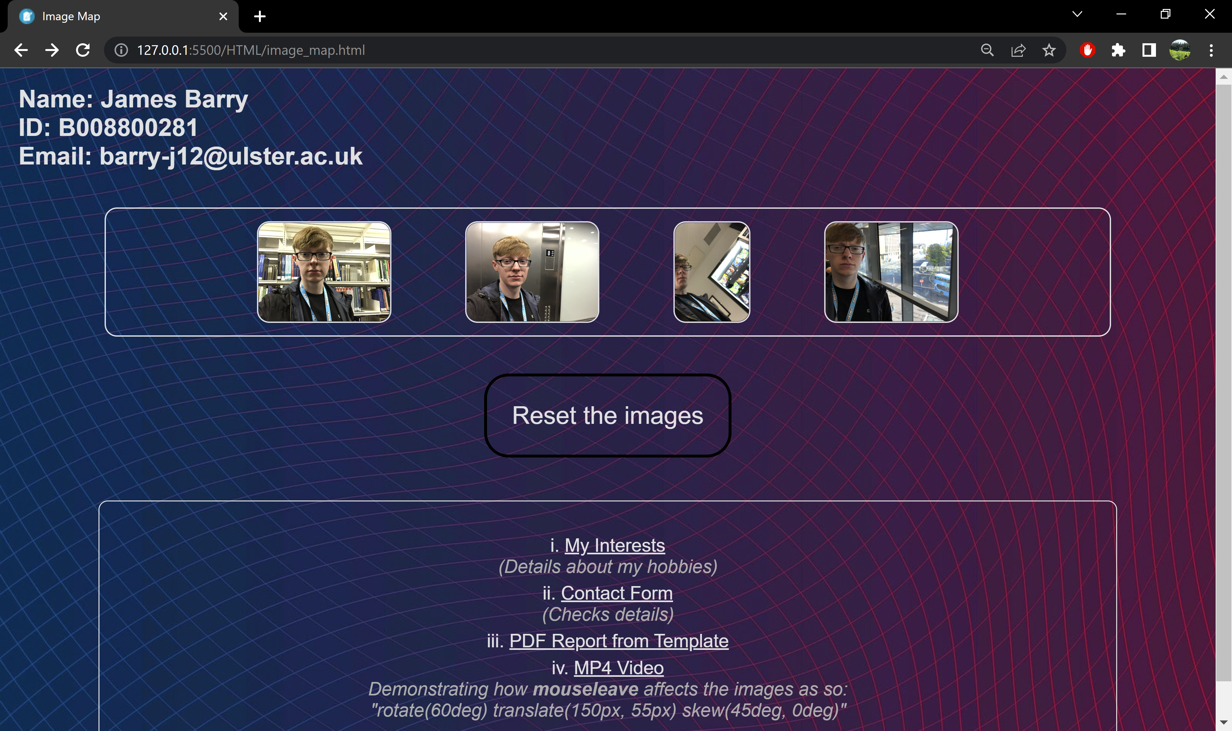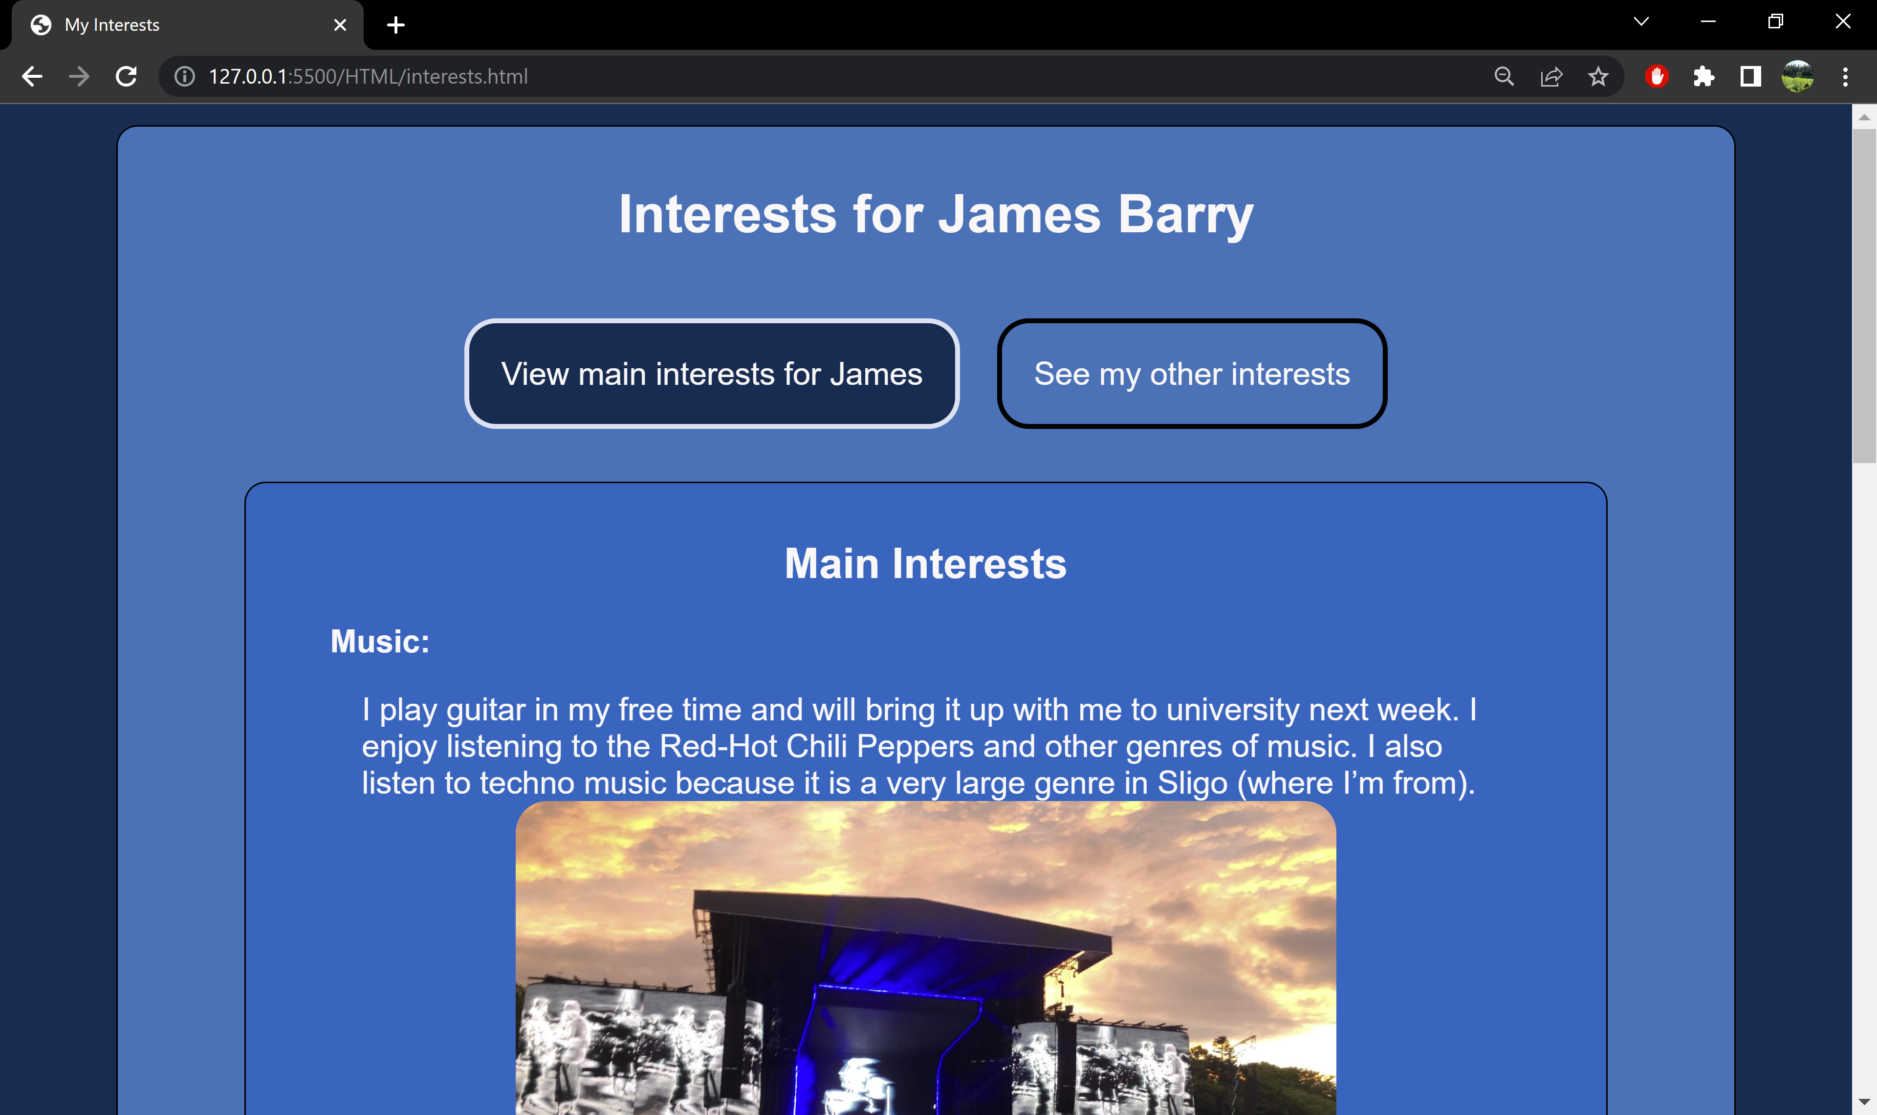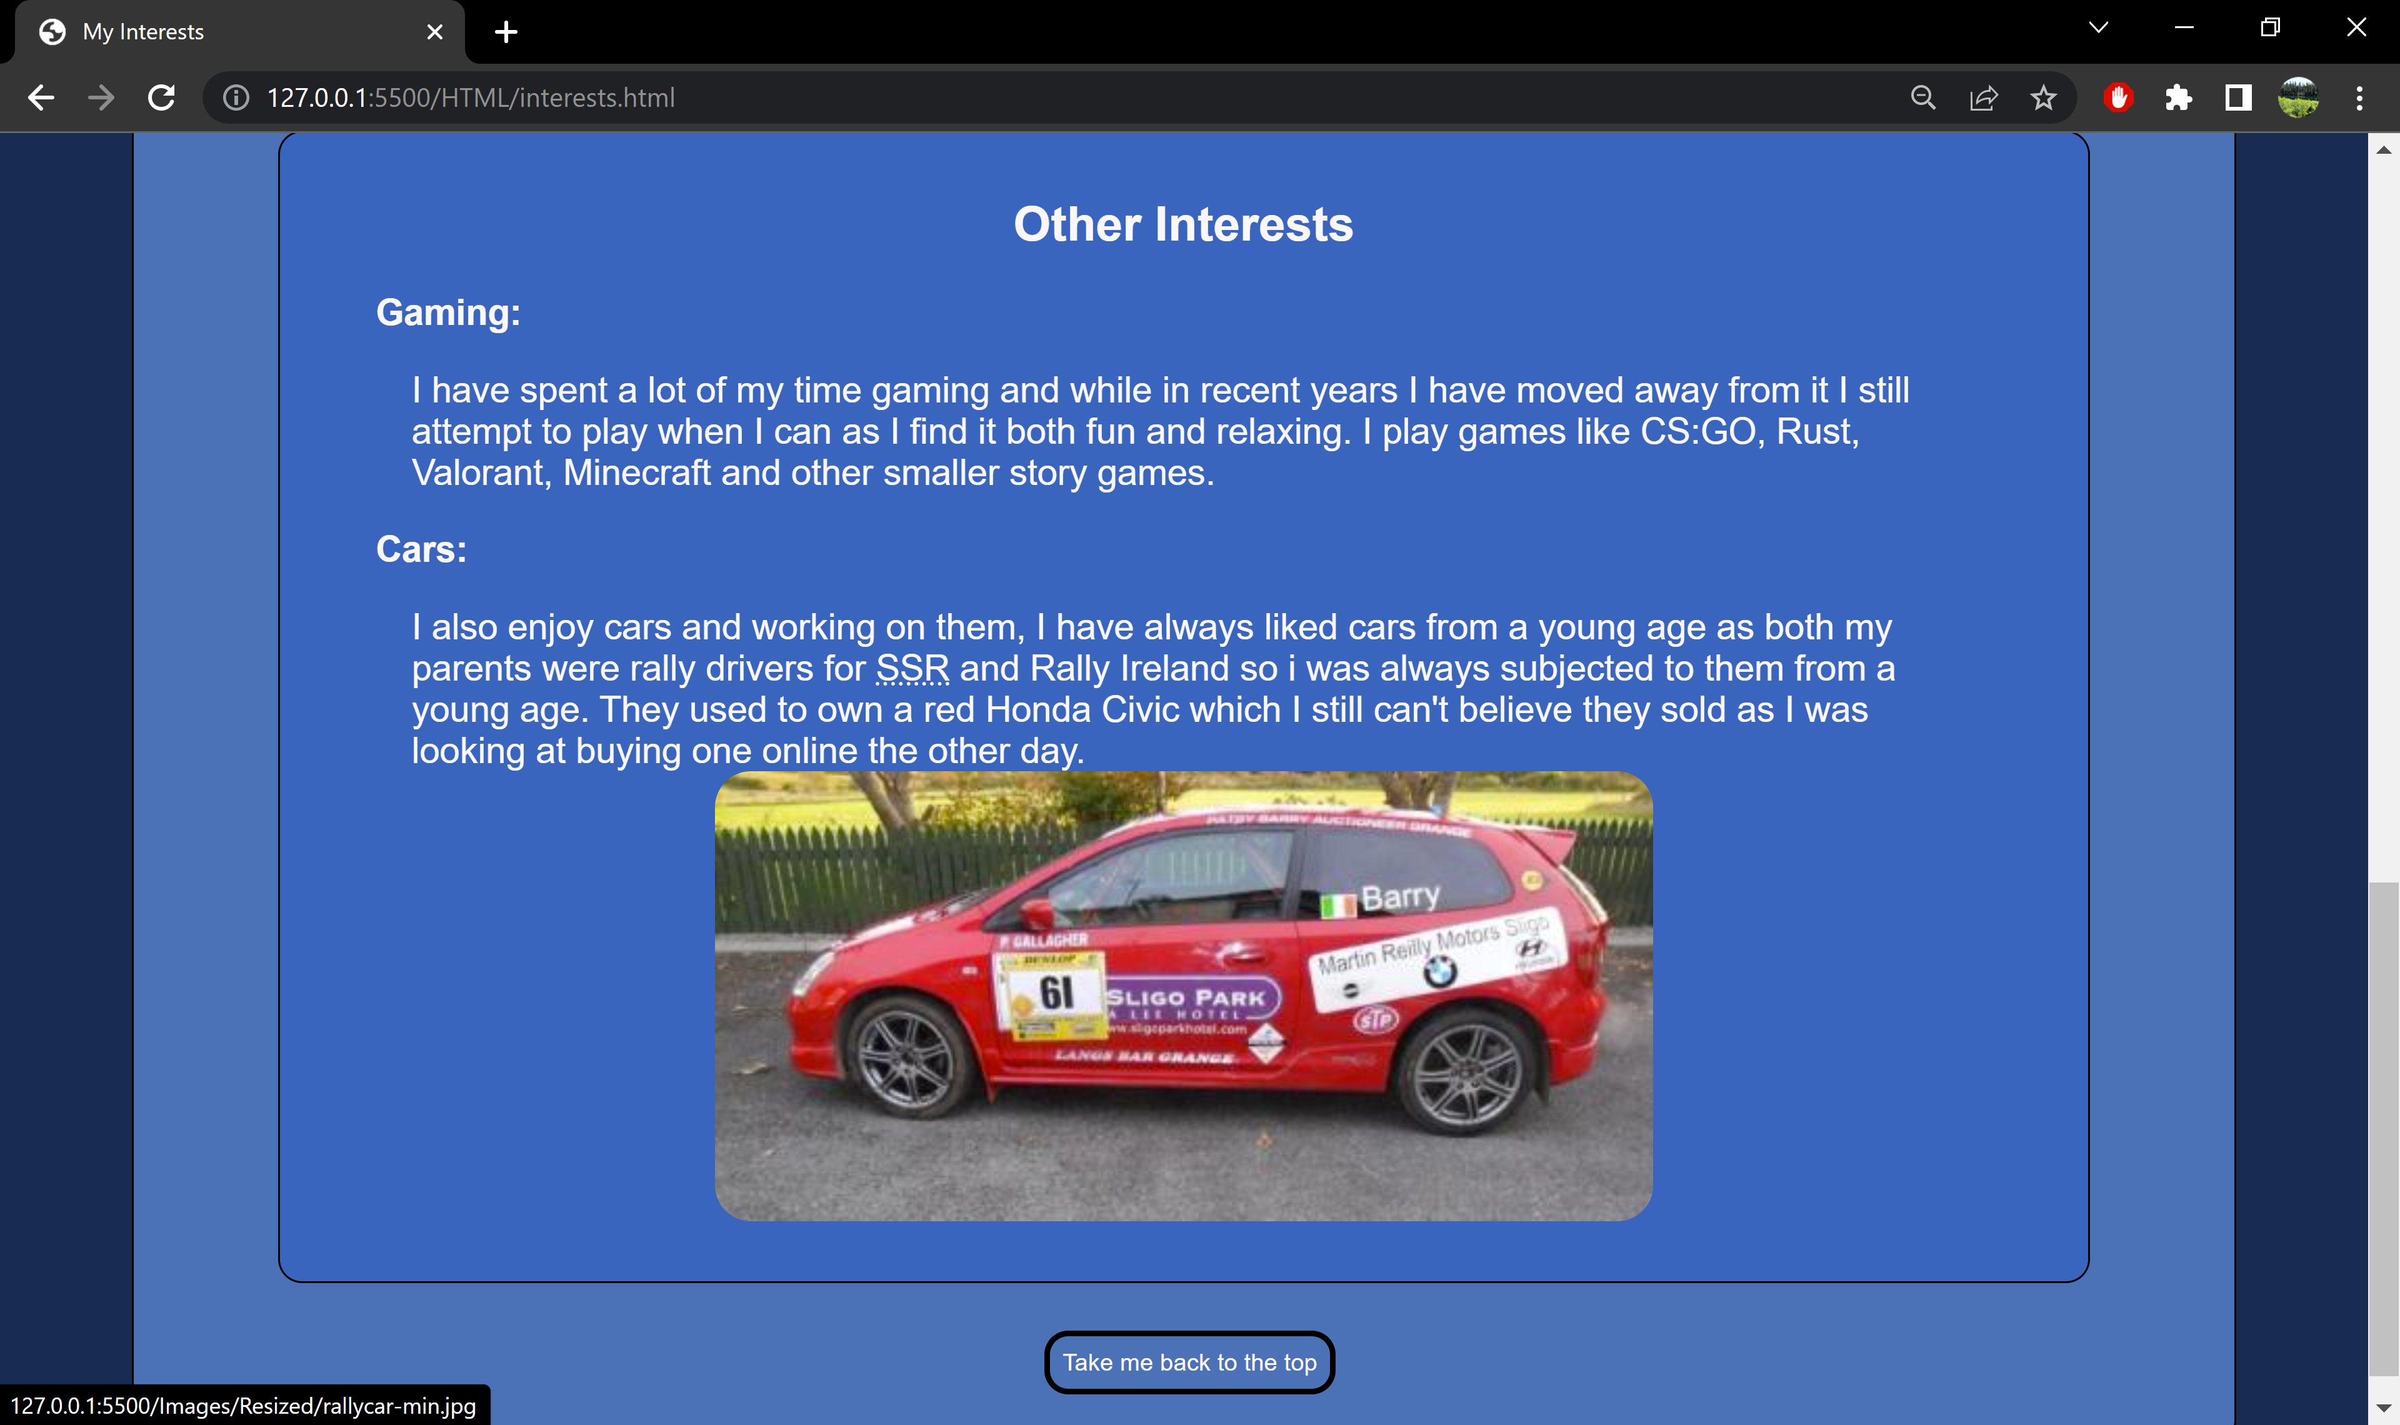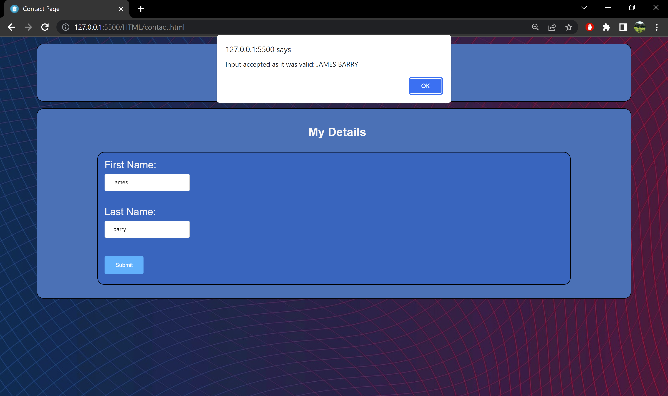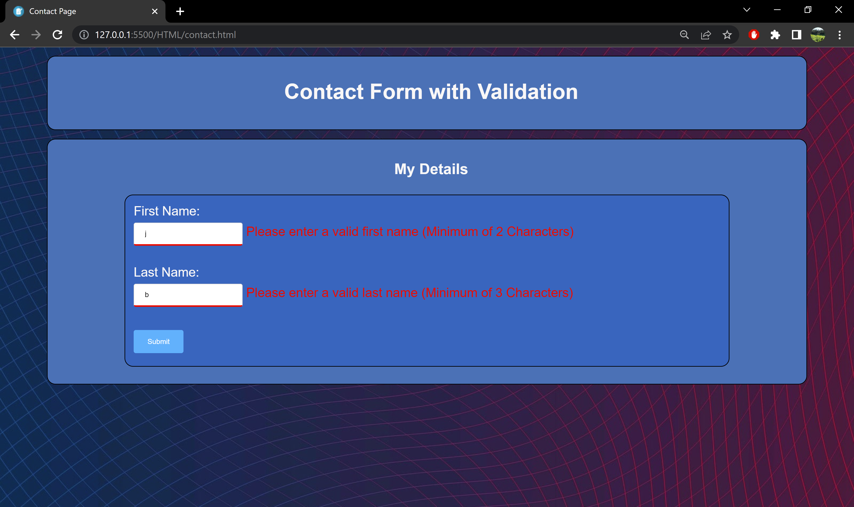

*Sample screenshots of image_map.html, contact.html & interests.html*

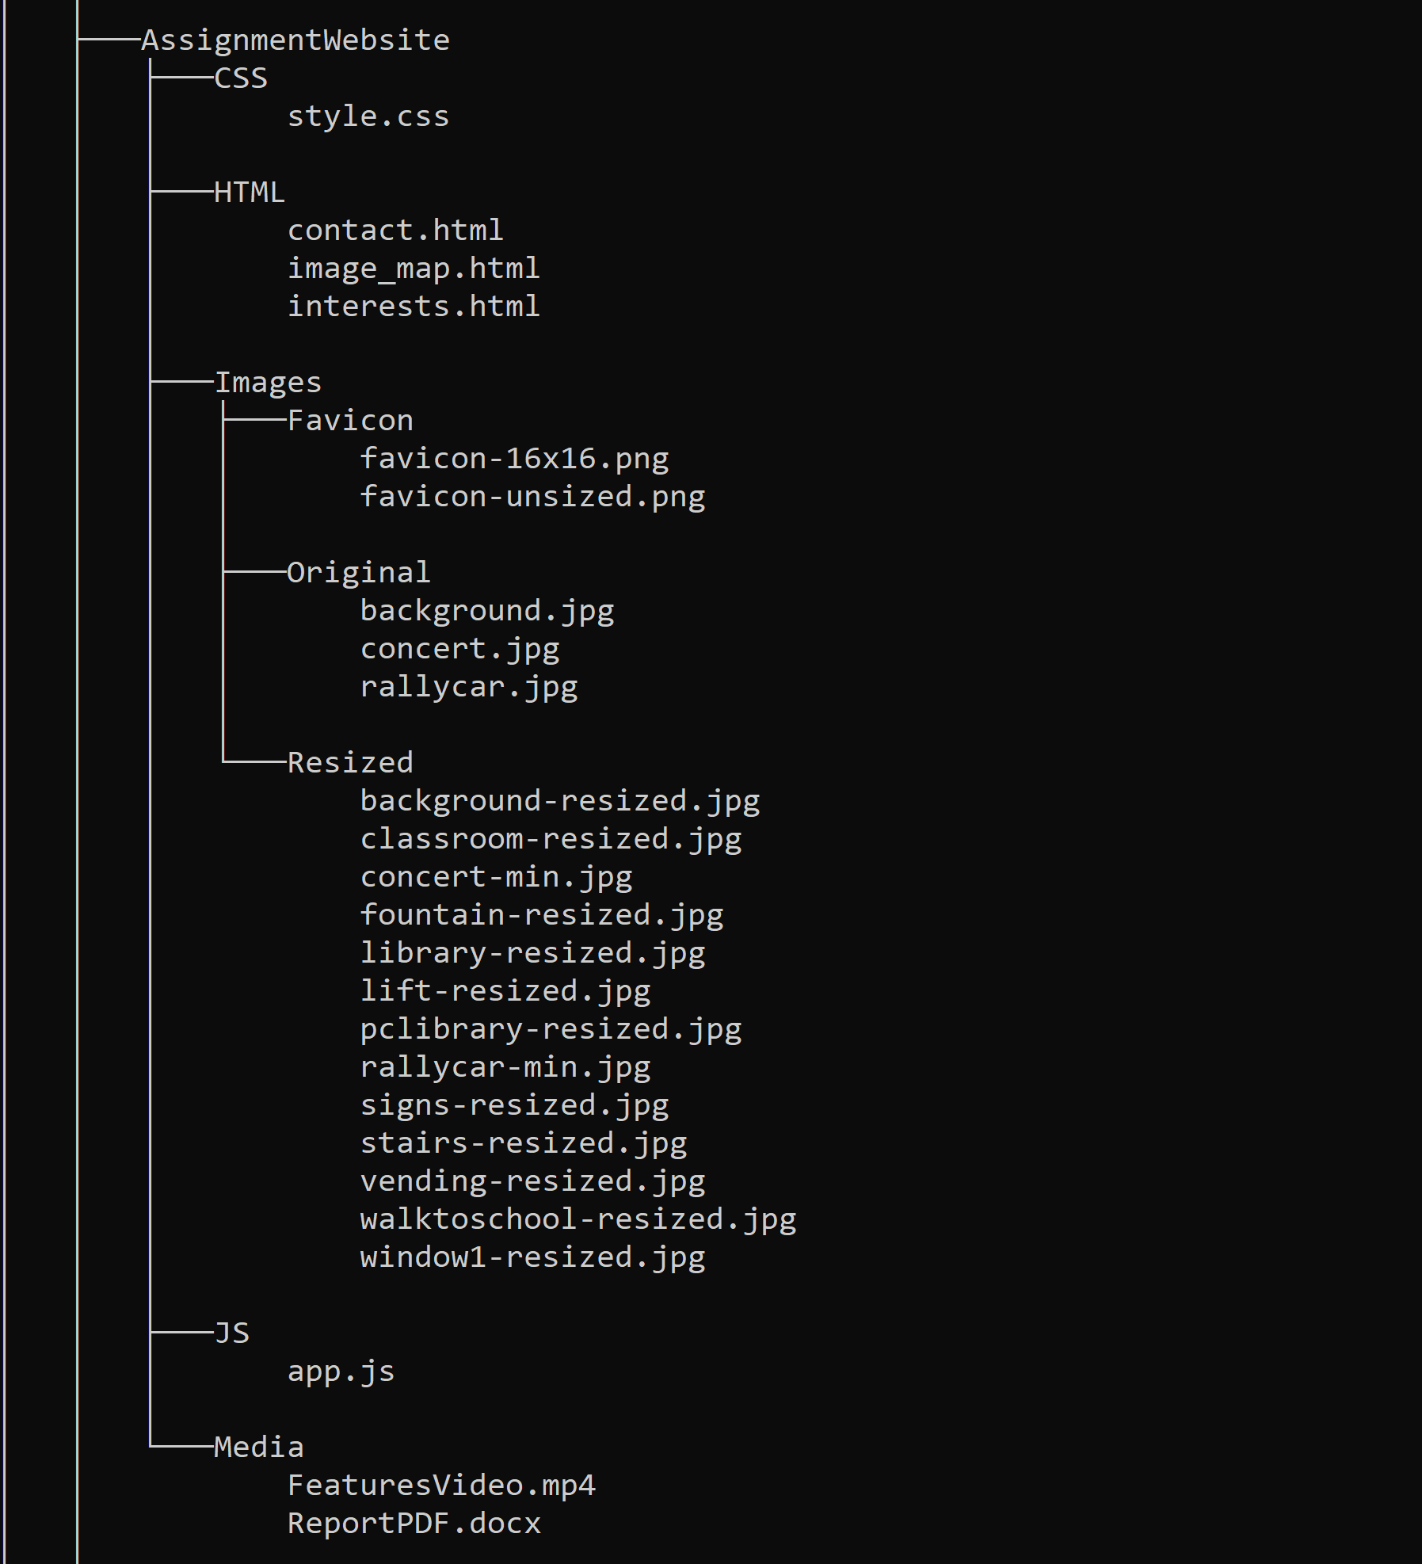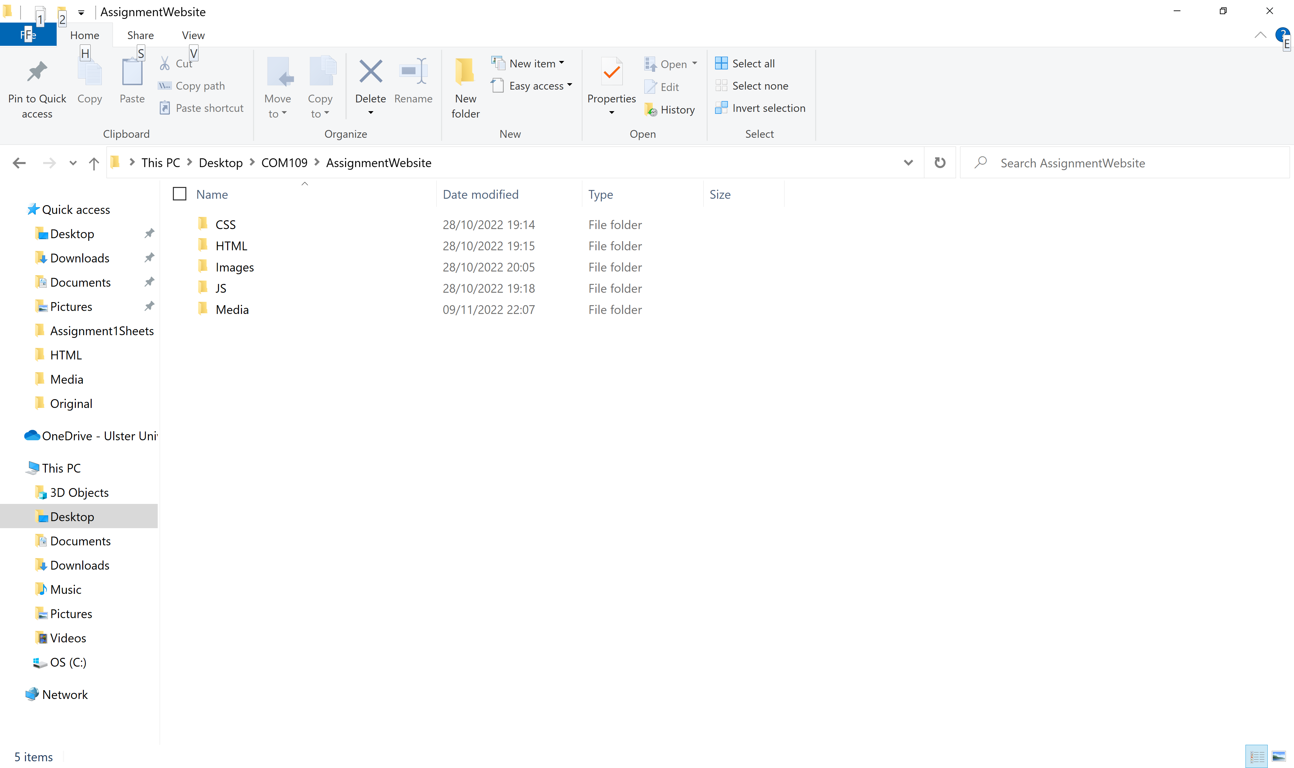

*Sample folder structure for all COM109 Assignment 1 work with clear identification for the image folders for the file sizes for pictures*

Code for imge_map.html, followed by contact.html and then interests.html using the Preview in <http://hilite.me>

HTML

*(Sample input to create the output required)*

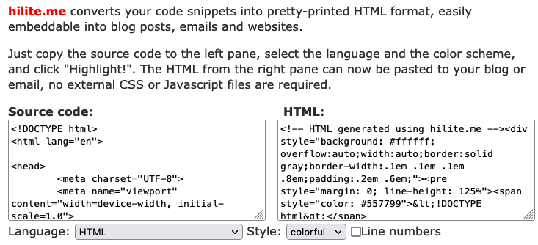

*HTML selected with NO line numbers with Preview copied and pasted as text*

**Image_map.html**

<!DOCTYPE html>

<html lang="en">

<head>

<meta charset="utf-8">

<meta name="Author" content="James Barry">

<meta name="Description" content="Assignement 1">

<meta name="Keywords" content="HTML, CSS, JQuery">

<link href="../Images/Favicon/favicon-16x16.png" rel="SHORTCUT ICON" type="image/x-icon">

<link rel="stylesheet" type="text/css" href="/CSS/style.css" media="screen">

<link href="#" rel="SHORTCUT ICON" type="image/x-icon">

<title>Image Map</title>

</head>

<body class="background">

<header>

<h1 class="info">Name: James Barry <br>

ID: B008800281<br>

Email: barry-j12@ulster.ac.uk</h1>

</header>

<div class="images">

<img src="/Images/Resized/library-resized.jpg" alt="A photo of myself at the library" id="images1" class="img1">

<img src="/Images/Resized/lift-resized.jpg" alt="Image of myself in the lift" id="images2" class="img2">

<img src="/Images/Resized/vending-resized.jpg" alt="Image of myself at the vending machine" id="images3" class="img3">

<img src="/Images/Resized/walktoschool-resized.jpg" alt="Image of myself above my walk to school" id="images4" class="img4">

</div>

<div class="centeredbtn">

<button class="btn">

Reset the images

</button>

</div>

<div class="center">

<ol class="lowerromanlist">

<li><a href="/HTML/interests.html" class="list">My Interests</a><br> <em>(Details about my hobbies)</em></li>

<li><a href="/HTML/contact.html" class="list">Contact Form</a><br> <em>(Checks details)</em></li>

<li><a href="../Media/ReportPDF.docx" class="list" target="_blank">PDF Report from Template</a></li>

<li><a href="../Media/FeaturesVideo.mp4" class="list" target="_blank">MP4 Video</a><br> <em>Demonstrating how <strong>mouseleave</strong> affects the images as so:

<br>"rotate(60deg) translate(150px, 55px) skew(45deg, 0deg)"</em></li>

</ol>

</div>

<script src="https://ajax.googleapis.com/ajax/libs/jquery/3.6.0/jquery.min.js"></script>

<script src="/JS/app.js"></script>

</body>

</html>

**Contact.html**

<!DOCTYPE html>

<html lang="en">

<head>

<meta charset="utf-8">

<meta name="Author" content="James Barry" >

<meta name="Description" content="Assignement 1" >

<meta name="Keywords" content="HTML, CSS, JQuery" >

<link href="../Images/Favicon/favicon-16x16.png" rel="SHORTCUT ICON" type="image/x-icon">

<link rel="stylesheet" type="text/css" href="/CSS/style.css" media="screen">

<link href="#" rel="SHORTCUT ICON" type="image/x-icon">

<title>Contact Page</title>

</head>

<body class="background">

<div class="interestspagebox">

<header>

<h1 class="interestsh1">Contact Form with Validation</h1>

</header>

</div>

<div class="interestspagebox">

<header>

<h2 class="contacth2">My Details</h2>

</header>

<div class="contactpageboxinside">

<form class="contact" target="_parent" id="form">

<label for="firstname">First Name: </label><br>

<input type="text" id="firstname" name="firstname">

<span class="Error" id="firstNameError">Please enter a valid first name (Minimum of 2 Characters)</span><br><br>

<label for="lastname">Last Name: </label><br>

<input type="text" id="lastname" name="lastname">

<span class="Error" id="lastNameError">Please enter a valid last name (Minimum of 3 Characters)</span><br><br>

<input type="submit">

</form>

</div>

</div>

<script src="https://code.jquery.com/jquery-3.6.1.min.js"></script>

<script src="/JS/app.js"></script>

</body>

</html>

**interests.html**

<!DOCTYPE html>

<html lang="en">

<head>

<meta charset="utf-8">

<meta name="Author" content="James Barry" >

<meta name="Description" content="Assignement 1" >

<meta name="Keywords" content="HTML, CSS, JQuery" >

<link rel="stylesheet" type="text/css" href="/CSS/style.css" media="screen">

<link href="#" rel="SHORTCUT ICON" type="image/x-icon">

<title>My Interests</title>

<style>

body {

**background-image**: **none**;

**background-color**: **#112D4E**;

}

</style>

</head>

<body>

<div class="interestspagebox">

<header>

<h1 class="interestsh1">Interests for James Barry</h1>

</header>

<div class="inlinebtn">

<button class="btn2" type="button">

View main interests for James

</button>

<button class="btn3">

See my other interests

</button>

</div>

<div class="maininterests" style="display:none;">

<div class="interestspageboxinside">

<h2 class="subtitle">Main Interests</h2>

<h3>Music:</h3>

<p class="text">

I play guitar in my free time and will bring it up with me to university next week.

I enjoy listening to the

Red-Hot Chili Peppers and other genres of music.

I also listen to techno music because it is a very large

genre in Sligo (where I**&rsquo;**m from).<br>

<a href="../Images/Resized/concert-min.jpg" target="_blank">

<img src="../Images/Resized/concert-min.jpg" alt="Photograph I took at RHCP Concert" height="350">

</a>

</p>

<h3>Exercise:</h3>

<p class="text">

I enjoy regular exercise as I find it calming and a great time to listen to music,

I also find it helps with my

coding as I can step away from a problem and explore my options in my head as I work out.

</p>

<h3>Cooking:</h3>

<p class="text">

I have worked as a chef for two summers,

so I have a keen interest in cooking and eating all different

kinds of foods and experimenting with my own dishes for my own enjoyment and the enjoyment of

others.

</p>

</div>

</div>

<div class="otherinterests" style="display:none;">

<div class="interestspageboxinside">

<h2 class="subtitle">Other Interests</h2>

<h3>Gaming:</h3>

<p class="text">

I have spent a lot of my time gaming and while in recent years I have moved away from it I still attempt

to play when I can as I find it both fun and relaxing. I play games like CS:GO, Rust, Valorant, Minecraft

and other smaller story games.

</p>

<h3>Cars:</h3>

<p class="text">

I also enjoy cars and working on them, I have always liked cars from a young age as both my parents were rally

drivers for <abbr title="Sligo Stages Rally">SSR</abbr> and Rally Ireland so i was always subjected to them from a young age. They used to own a red Honda Civic which I still

can't believe they sold as I was looking at buying one online the other day.<br>

<a href="../Images/Resized/rallycar-min.jpg" target="_blank">

<img src="../Images/Resized/rallycar-min.jpg" alt="My parents red Honda Civic" height="300">

</a>

</p>

</div>

</div>

<div class="inlinebtn">

<button class="btn4" type="button" onclick="topFunction()">

Take me back to the top

</button>

</div>

</div>

<script src="https://code.jquery.com/jquery-3.6.1.min.js"></script>

<script>

$(document).ready(**function**() {

$(**function**() {

$(".btn2").on("click",**function**() {

$(".maininterests").slideToggle();

});

});

$(**function**() {

$(".btn3").on("click",**function**() {

$(".otherinterests").slideToggle();

});

});

$(".btn4").click(**function**(){

$("html, body").animate({ scrollTop: **0** }, "slow");

**return** **false**;

});

});

</script>

</body>

</html>

External CSS used for the three web pages of image_map.html, contact.html & interests.html

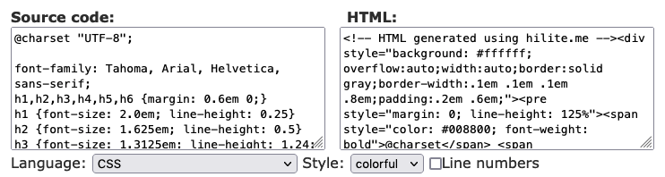

*CSS selected* *with NO line numbers with Preview copied and pasted as text*

**@charset** "UTF-8";

**.info** {

**font-family**: **sans-serif**;

**color**: **#eeee**;

}

**.background** {

**background-image**: url(/Images/Resized/background-resized.jpg);

**background-repeat**: **repeat-y**;

**background-attachment**: **fixed**;

}

**.lowerromanlist** {

**list-style**: **lower-roman**;

**color**: **#eeee**;

**font-size**: **1.5em**;

**border**-radius: **0.5em**;

**border-style**: **solid**;

**padding**: **1.5em** **1em** **1.5em** **1em**;

**margin-left**: **5em**;

**margin-right**: **5em**;

**list-style-position**: **inside**;

}

**.list** {

**color**: **#eeee**;

}

**.center** {

**text-align**: **center**;

}

header {

**margin-bottom**: **2em**;

**margin-left**: **1em**;

}

**#images1** {

**height**: **8**rem;

**margin**: **1**rem **3**rem **1**rem **3**rem;

**border-style**: **solid**;

**border**-radius: **1**rem;

**border-width**: **2px**;

**border-color**: **#eeee**;

}

**#images2** {

**height**: **8**rem;

**margin**: **1**rem **3**rem **1**rem **3**rem;

**border-style**: **solid**;

**border**-radius: **1**rem;

**border-width**: **2px**;

**border-color**: **#eeee**;

}

**#images3** {

**height**: **8**rem;

**margin**: **1**rem **3**rem **1**rem **3**rem;

**border-style**: **solid**;

**border**-radius: **1**rem;

**border-width**: **2px**;

**border-color**: **#eeee**;

}

**#images4** {

**height**: **8**rem;

**margin**: **1**rem **3**rem **1**rem **3**rem;

**border-style**: **solid**;

**border**-radius: **1**rem;

**border-width**: **2px**;

**border-color**: **#eeee**;

}

**.images** {

align-items: **center**;

**justify**-**content**: **center**;

**display**: flex;

**border-style**: **solid**;

**border**-radius: **1**rem;

**border-width**: **2px**;

**border-color**: **#eeee**;

**margin**: **3**rem **8**rem **3**rem **8**rem;

}

**.btn** {

**font-family**: **sans-serif**;

**border**: **4px**;

**border-style**: **solid**;

**border-color**: black;

**text-align**: **center**;

**padding**: **1em** **1em** **1em** **1em**;

**background-color**: rgba(**74**, **74**, **124**, **0**);

**font-size**: **2em**;

**border**-radius: **1em**;

**color**: **#eeee**;

**cursor**: **pointer**;

transition-duration: **0.3s**;

**margin-bottom**: **1em**;

}

**.btn:hover** {

**border-color**: **#eeee**;

**background-color**: **rgb**(**34**, **105**, **185**);

}

**.centeredbtn** {

**justify**-**content**: **center**;

**display**: flex;

}

li {

**margin-top**: **0.3em**;

**font-family**: Arial, Helvetica, **sans-serif**;

**font-size**: **1em**;

}

**#nolink** {

**text-decoration**: **none**;

}

em {

**color**: rgba(**184**, **181**, **181**, **0**.**933**);

}

li a**:hover** {

**color**: **rgb**(**44**, **124**, **215**);

}

**.inlinebtn** {

**text-align**: **center**;

}

/* interests page */

**.btn2** {

**font-family**: **sans-serif**;

**border**: **4px**;

**border-style**: **solid**;

**border-color**: black;

**text-align**: **center**;

**padding**: **1em** **1em** **1em** **1em**;

**background-color**: rgba(**74**, **74**, **124**, **0**);

**font-size**: **1.5em**;

**border**-radius: **1em**;

**color**: **#F9F7F7**;

**cursor**: **pointer**;

transition-duration: **0.3s**;

**margin-bottom**: **1em**;

**margin-top**: **1em**;

**margin-right**: **0.5em**;

}

**.btn2:hover** {

**border-color**: **#DBE2EF**;

**background-color**: **#112D4E**;

}

**.btn3** {

**font-family**: **sans-serif**;

**border**: **4px**;

**border-style**: **solid**;

**border-color**: black;

**text-align**: **center**;

**padding**: **1em** **1em** **1em** **1em**;

**background-color**: rgba(**74**, **74**, **124**, **0**);

**font-size**: **1.5em**;

**border**-radius: **1em**;

**color**: **#F9F7F7**;

**cursor**: **pointer**;

transition-duration: **0.3s**;

**margin-bottom**: **1em**;

**margin-top**: **1em**;

**margin-left**: **0.5em**;

}

**.btn3:hover** {

**border-color**: **#DBE2EF**;

**background-color**: **#112D4E**;

}

**.btn4** {

**font-family**: **sans-serif**;

**border**: **4px**;

**border-style**: **solid**;

**border-color**: black;

**text-align**: **center**;

**padding**: **0.5em** **0.5em** **0.5em** **0.5em**;

**background-color**: rgba(**74**, **74**, **124**, **0**);

**font-size**: **1em**;

**border**-radius: **1em**;

**color**: **#F9F7F7**;

**cursor**: **pointer**;

transition-duration: **0.3s**;

**margin-bottom**: **1em**;

**margin-top**: **1em**;

**margin-left**: **0.5em**;

}

**.btn4:hover** {

**border-color**: **#DBE2EF**;

**background-color**: **#112D4E**;

}

**.interestspageboxinside** {

**border-style**: **solid**;

**background-color**: **#2767b6**;

**padding**: **1em** **1em** **1em** **1em**;

**margin**: **1em** **5em** **1em** **5em**;

**border**-radius: **1em**;

}

**.interestspagebox** {

**border-style**: **solid**;

**background-color**: **#3F72AF**;

**padding**: **1em** **1em** **1em** **1em**;

**margin**: **1em** **5em** **1em** **5em**;

**border**-radius: **1em**;

}

**.interestsh1** {

**font-family**: Arial, Helvetica, **sans-serif**;

**color**: **#F9F7F7**;

**font-size**: **2.5em**;

**text-align**: **center**;

}

**.text** {

**margin-left**: **3em**;

**margin-right**: **3em**;

**color**: **#F9F7F7**;

**font-size**: **1.5em**;

**font-family**: Arial, Helvetica, **sans-serif**;

}

**.subtitle** {

**color**: **#F9F7F7**;

**font-size**: **2em**;

**font-family**: Arial, Helvetica, **sans-serif**;

**text-align**: **center**;

}

h3 {

**font-family**: Arial, Helvetica, **sans-serif**;

**color**: **#F9F7F7**;

**margin-left**: **2em**;

**font-size**: **1.5em**;

}

a img {

**display**: **block**;

**margin-left**: **auto**;

**margin-right**: **auto**;

**border**-radius: **1em**;

}

**.contacth2** {

**font-family**: Arial, Helvetica, **sans-serif**;

**color**: **#F9F7F7**;

**font-size**: **1.75em**;

**text-align**: **center**;

}

**.contact** {

**color**: **#F9F7F7**;

**font-size**: **1.5em**;

**font-family**: Arial, Helvetica, **sans-serif**;

}

**.contactpageboxinside** {

**border-style**: **solid**;

**background-color**: **#2767b6**;

**padding**: **1em** **1em** **1em** **1em**;

**margin**: **1em** **8em** **1em** **8em**;

**border**-radius: **1em**;

}

**#firstname**{

**border-bottom**: **3px** **solid** **#F9F7F7**;

**padding**: **12px** **20px**;

**margin**: **8px** **0**;

**display**: **inline**-**block**;

**border**: **1px** **solid** **#ccc**;

**border**-radius: **4px**;

box-sizing: **border**-box;

}

**#lastname** {

**border-bottom**: **3px** **solid** **#F9F7F7**;

**padding**: **12px** **20px**;

**margin**: **8px** **0**;

**display**: **inline**-**block**;

**border**: **1px** **solid** **#ccc**;

**border**-radius: **4px**;

box-sizing: **border**-box;

}

**.Error** {

**color**: **#F90A0A**;

**font-family**: helvetica;

}

input[type=submit] {

**background-color**: **#3995cf**;

**color**: white;

**padding**: **14px** **20px**;

**margin**: **8px** **0**;

**border**: **none**;

**border**-radius: **4px**;

**cursor**: **pointer**;

**width**: **7em**;

}

input[type=submit]**:hover** {

**background-color**: **#49b2f4**;

}

[API](http://hilite.me/api) • [C](https://github.com/alexkay/hilite.me)

jQuery – app.js

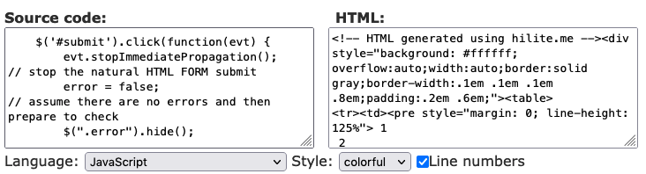

*JavaScript selected* *WITH line numbers with Preview copied and pasted as text*

|  |  |
| --- | --- |
| 1  2  3  4  5  6  7  8  9  10  11  12  13  14  15  16  17  18  19  20  21  22  23  24  25  26  27  28  29  30  31  32  33  34  35  36  37  38  39  40  41  42  43  44  45  46  47  48  49  50  51  52  53  54  55  56  57  58  59  60  61  62  63  64  65  66  67  68  69  70  71  72  73  74  75  76  77  78  79  80  81  82  83  84  85  86  87  88  89  90  91  92  93  94  95  96  97  98  99  100  101  102  103  104  105  106  107  108  109  110  111  112  113  114  115  116  117  118  119  120  121  122  123  124  125  126  127 | $(document).ready(**function**() {  $(".img1").mouseleave(**function**() {  $(**this**).css({  transform: 'rotate(60deg) translate(150px, 55px) skew(45deg, 0deg)'  });  })  /*button to reset start */  $(".img1").keypress(**function**() {  $(**this**).css({  transform: 'rotate(0deg) translate(0px, 0px) skew(0deg, 0deg)'  });  })  $(".btn").click(**function**() {  $(".img1").keypress();  });  /*button to reset end */  $(".img2").mouseleave(**function**() {  $(**this**).css({  transform: 'rotate(60deg) translate(150px, 55px) skew(45deg, 0deg)'  });  })  $(".img2").keypress(**function**() {  $(**this**).css({  transform: 'rotate(0deg) translate(0px, 0px) skew(0deg, 0deg)'  });  })  $(".btn").click(**function**() {  $(".img2").keypress();  });  $(".img3").mouseleave(**function**() {  $(**this**).css({  transform: 'rotate(60deg) translate(150px, 55px) skew(45deg, 0deg)'  });  })  $(".img3").keypress(**function**() {  $(**this**).css({  transform: 'rotate(0deg) translate(0px, 0px) skew(0deg, 0deg)'  });  })  $(".btn").click(**function**() {  $(".img3").keypress();  });  $(".img4").mouseleave(**function**() {  $(**this**).css({  transform: 'rotate(60deg) translate(150px, 55px) skew(45deg, 0deg)'  });  })  $(".img4").keypress(**function**() {  $(**this**).css({  transform: 'rotate(0deg) translate(0px, 0px) skew(0deg, 0deg)'  });  })  $(".btn").click(**function**() {  $(".img4").keypress();  });  /* END OF IMAGE MAP JQUERY */  $(**function**() {  $("#firstNameError").hide();  $("#lastNameError").hide();  **var** error_fname = **false**;  **var** error_lname = **false**;  $("#firstname").focusout(**function**(){  check_firstname();  });    $("#lastname").focusout(**function**(){  check_lastname();  });  **function** check_firstname() {  **var** firstname_length = $("#firstname").val().length;  **if** (firstname_length < **2**) {  $("firstNameError").html("At least 2 Characters");  $("#firstname").css("border-bottom", "3px solid #F90A0A");  $("#firstNameError").show();  error_fname = **true**;  } **else** {  $("firstNameError").hide();  $("firstname").css("border-bottom", "3px solid #FFFF")  }  }  **function** check_lastname() {  **var** lastname_length = $("#lastname").val().length;  **if** (lastname_length < **3**) {  $("lastNameError").html("At least 2 Characters");  $("#lastname").css("border-bottom", "3px solid #F90A0A");  $("#lastNameError").show();  error_lname = **true**;  } **else** {  $("lastNameError").hide();  $("lastname").css("border-bottom", "3px solid #FFFF")  }  }  $("#form").submit(**function**(event){  event.preventDefault();  **let** fname = $("#firstname").val();  **let** lname = $("#lastname").val();  error_fname = **false**;  error_lname = **false**;  check_firstname();  check_lastname();  **if** (error_fname === **false** && error_lname === **false**) {  alert("Input accepted as it was valid: " + fname.toUpperCase() + " " + lname.toUpperCase());  **return** **true**;  } **else** {  alert("Input rejected as it was invalid")  **return** **false**;  }    });    });  }); |

W3C Validation Report for interests.html file using: [https://validator.w3.org/nu/#file](https://validator.w3.org/nu/" \l "file)

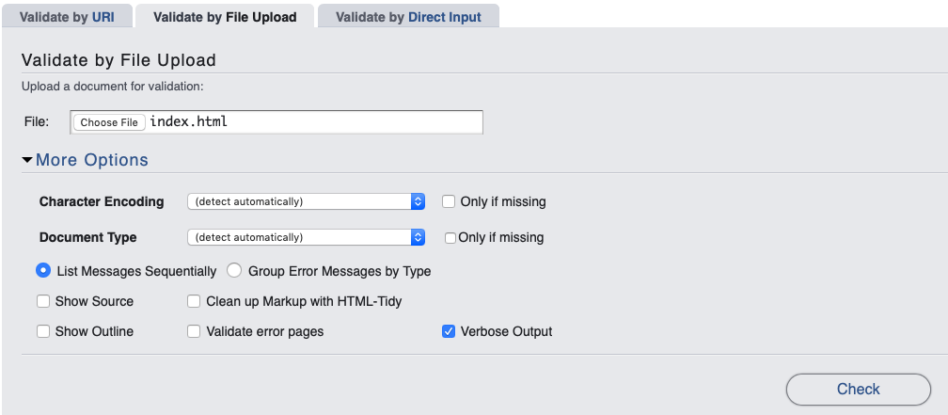

*Verbose Output selected*

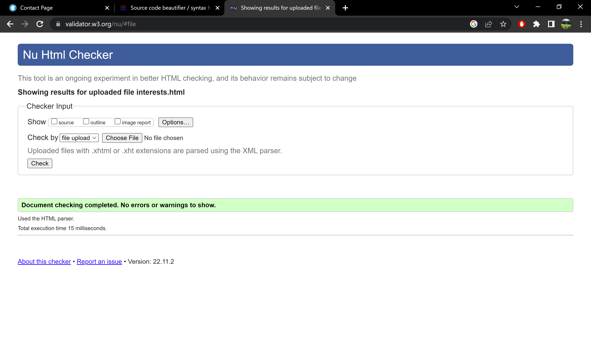

Sources

<https://www.w3schools.com/js/>

<https://pixabay.com/>